**Big Data Analytics in Healthcare**

Guorong Chen, Mohaiminul Islam

School of Intelligent Technology and Engineering

Chongqing University of Science and Technology

Chongqing, China

Email: [cgr@cqust.edu.cn,](mailto:cgr@cqust.edu.cn,) [mohaiminul100@hotmail.com](mailto:mohaiminul100@hotmail.com)

# *Abstract—***Big data is a new area of computer science. The concept of big data gained momentum in the early 2000s. Big data is so large, complex and fast. Analytics is very much related to big data. It has the ability to provide useful acumen in healthcare. Big data nevertheless impending manifestation in its jurisprudence and assumption, similar as like diversity, celerity, honestly, and merit, exactness, fairness, and semantic illustration are of bigger anxiety in medical applications. Big Data has changed lead, explore data in many craft, especially in healthcare. The good news is we can use big data to change the healthcare industry. By using big data it is very much possible to make a better healthcare industry. Healthcare analytics can abate the treatment cost, foretell outbreaks of murrain, get off preventable illness also exaggerate the attribute of breath in ordinary. People live longer now than ever before. Nowadays doctors use new advance technology to predict patient's diseases. Among **this article, we would like to clue the importance of big data in healthcare, big data analytics advantages in the healthcare system, big data applications and examples in healthcare, challenges of big data analytics. At the end, applying proficient and streamlined analytics to big data will set to swift and exact diagnosis, apposite treatment, abate charges, and elevated aggregate healthcare virtue.****

***Keywords— Big Data, Analytics, Healthcare, Prediction, Diseases, Patient***

1. **Introduction**

A report is saying that now the world population is almost 7.7 billion. Every day the population and people's lifestyle is changing. It's increasing pressure on healthcare systems in the region of the world. These aptitudes associated with the modernization of health and patient information by pledge in information technology, including galenical sensors, have led to the generation of massive altars of elementary, subordinate data inside healthcare domain. The requirement for big data is also pluck by a changing to testimony-based prescript as disinterested in secular clinical reasoning. When the trove of data offers important advantage for developing healthcare delivery, administration, and policymaking, data schemes,accession are needed to make effective use of the big data. Indeed, big data has been referred to as data that is too large and depth to be resolved and guided by traditionary computing products.

There are several big data analytics applications invented for the healthcare industry. These applications have some good results. Every healthcare industry has a huge amount of data. It will use appointed health data of a demography and potentially aid to obstruct murrain, healing disease, retrench the treatment costs, etc[1]. Now we live longer, scientists are inventing new kinds of medicine and treatment for patients. Treatment varsities have reciprocal and many of these changes are videlicet by data. Doctors want to appreciate about a patient as soon as they can. It is very necessary to understand the patient's disease and problems. If a doctor can understand the disease, it is very much possible to prevent the disease. Forbearance is good than medication and governing to describe a widespread photo of a patient will let assurances bargain a bunch.

1. **Importance Of Big Data Analytics In Healthcare**

Before know the importance of big data analytics in healthcare, we first need to know about the value of data. Healthcare data management is one kind of process of analyzing all kinds of data collected from several sources. It helps the healthcare industry to treat their patients more carefully and accurately.

**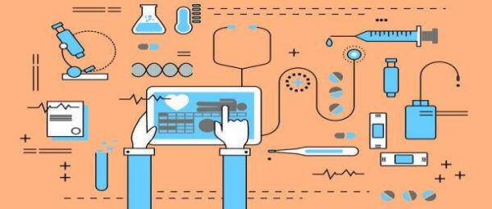**

*****Figure 1. Medical Data Analytics diagram*****

Health Catalyst published a report about it. According to the report, a whopping 87% of the respondents admitted that analytics is going to be either immensely momentous or very momentous to their organization within the next few years. The healthcare industry has a massive amount of data sets. All of this data can come from different sectors of healthcare organization specially from labs, medical practitioner notes, and even CRM systems. Nowadays all the healthcare organization collects and capture all the patient's data and every piece of information. This kind of new technology is used in healthcare to get better results that can favor diagnosis and disposition for patients. Gearing big data can help attain three troublesome objectives in healthcare:

* **Fabricate preservable healthcare systems: Healthcare organizations always work with complex and serious matters. The treatment cost is very high for some diseases especially cancer, HIV and some other diseases. Healthcare organizations can do something here. They can reduce the treatment cost. The healthcare industry also can give a mind to improving patients treatment.**
* **Enhance care: Every patients spend lots of money to get good service from healthcare organizations. But nowadays we can see many healthcare industries don't care about patient's care and quality. It's very harmful to patients. A patient's family spends a huge amount of money to save his life. By using healthcare data all the healthcare industry can build a suitable and good environment for patients.**
* **Enhancement ingress to healthcare: Here is an important issue with healthcare and it is accessed. The world population is growing very fast but the healthcare organization is not developing fast. Healthcare organizations must need to update them as soon as possible. by doing this they can provide better care to every patient[2].**

1. **Big Data Analytics Advantages In Healthcare System**

Technology changed our whole world. Nowadays we can see where people using modern technology to make their life more easy and comfortable. In modern days robot's is working in car, plane industry and it's working better than a man. In the medical sector, modern technology helps a lot to develop the treatment and care for patients. New technology is boosting up the medical sector. We can see in a hospital now doctor use digital health record, machines to predict patients diseases.The appearance of new technology has bestowed much stead to healthcare providers.Big data also changing the healthcare industry.

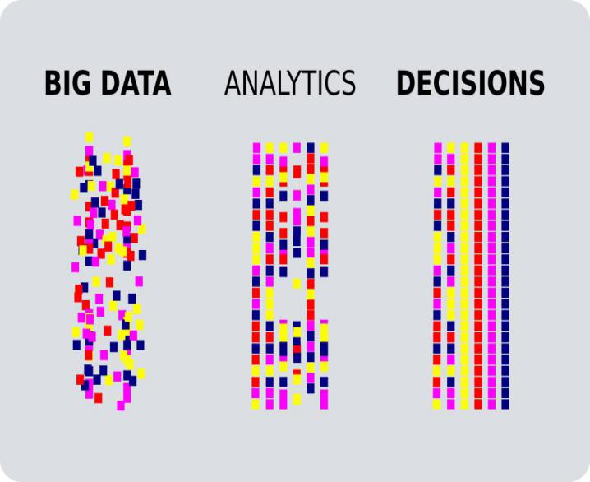

***Figure 2. Diagram***

Figure one is showing a diagram. Here are three steps of big data analytics. The first step is data collection. There is various source of data. After collecting the data there are several tools to process, visualize, analysis the data. In the end, it's time to make a decision. An analytics report helps the doctor to understand the patient's disease well. By using big data can help healthcare organization players to bargain more efficient operations and insights into the patients and their health. In the healthcare industry, big data have several benefits**.**An individual prescript seems to work for some people but not for others, and there are many things to be audited in an unaccompanied genome. It is not feasible to study all of them in detail[3]. But big data can help in uncovering unknown contextual, mystical patterns, and insights by examining chuckle sets of data. By factive machine learning, big data can study human genomes and find apposite treatment or drugs to treat cancer.

1. **Big Data Applications and Examples In Healthcare**

### Healthcare analytics changing the treatment model. The healthcare industry is now using several kinds of healthcare applications like Electronic Health Records. Every patient has their data. Paper data is a little bit old. Paper data can destroy easily. To solve this problem developer invented electronic health records. By using EHRs a patients can save all of his data easily online. EHRs are one of the most massive and useful applications in the healthcare industry. Patients have a test report, demographic, x-ray. By using electronic health records it is easy to transfer to doctors or other people easily.

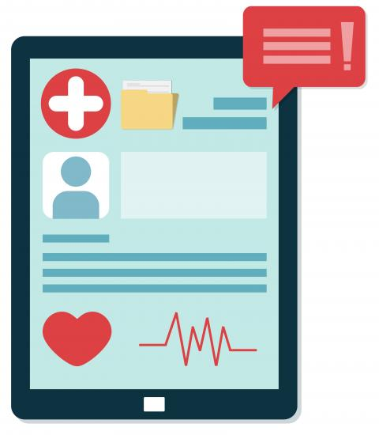

***Figure 3. EHRs Demo***

**In the healthcare industry, the authority uses some other applications such as Real-Time Alerting, Enhancing Patient Engagement, Predictive Analytics, Reduce Fraud And Enhance Security, Novartis Genomics, Prevent Unnecessary ER Visits.**

**Real-Time Alerting application, helps doctors to make decisions. In a hospital, all the system depends on software. As an example, if a patients blood pressure will increase suddenly this application will give a message to the doctor. The doctor can control it easily from his home or his office. Sometimes at midnight in-hospital doctors can go back to his house to take rest[4]. In this situation, if the patient will face any problem the real-time alerting system is enough to control the situation. Enhancing Patient Engagement, this application records every step of patients. It helps the doctor to understand patients' conditions much better than previous.Predictive Analytics, helps the doctor to take decisions more correctly. The doctor first collects all the data from the patients and test report. After collect all of these data doctors can analyze this data and can give a correct decision for patients.**

**Reduce Fraud And Enhance Security, this application help healthcare organization to find out the fraud person. This application can detect the cyber attack and can give an alarm to the authority. Data security is not of the most important issue of the healthcare organization. So the organization must need to ensure data security. Prevent Unnecessary ER Visits, applications help to control visitors. In a hospital of course, you don't want to see unnecessary people. If in a hospital have so many people it will be noisy and harmful for patients. So this software can help to find out the unnecessary ER visitors[5]. Big data analytics is now using in various fields, especially in the healthcare industry to understand patients better, to predict the diseases.**

1. **Challenges Of Big Data Analytics In Healthcare**

Big Data is a new area. It's developing fast, and new challenges await it. Using big data, we can make many advances in medical science. Currently, many hospitals are trying to improve their overall management system by using patients' data. In future several challenges is waiting in the medical sector. The medical sector is very complex. If the doctor does any mistake it will call a big danger. The most challenging task to use big data in healthcare is adoption, cleaning, storage.

### *Adoption*

For the adoption of the first stage, data must be sourced from a location with unimpeachable data governance practice if it is to be indeed clean, entire, well-formatted and accurate. It is a common disclosure for data to be skewed owing to the poor HER usability, expanded work flows and little understanding of the quintessence of big data in the whole procedure. To solve this, however, there’s a need for providers to fine-tune their data adoption routines, prioritize valuable data, fare data governance experts and coach clinicians on how to make the information for analytics.

### ***Cleaning***

Dirty data can destroy a big data analytics project easily. Before analyzing the data must need to be sure the data is clean. If the data is not clean the project will not be complete or it will give the wrong result. Cleanliness in proficiency is of utmost importance, and the same is true with the data. If it is dirty, the data may ultimately derail the project. And so, manual cleaning done by IT bargainer skilled in comparing and contradicting and determining big data-sets should be hired. It is only by so doing that accuracy will be achieved with integrity.

### ***Storage***

Big data contains a large amount of data. To store this data need big storage. It is natural for front-line clinicians not to question where the data is to be stored. With the amount of healthcare data growing, however, some providers will strive to keep accommodating the immense costs by having a data center. On-premise data centers guarantee easy access and rule and [security](https://datafloq.com/read/?q=Security" \l "utm=internal" \t "_blank), every healthcare organization collect all kinds of data. All of the patients have lots of records, images, and notes. It's much more difficult for the industry to store all of the data on the server. It's also so costly to store large amounts of data.[Cloud](https://datafloq.com/read/?q=Cloud" \l "utm=internal" \t "_blank) storage is the norm nowadays, even in the healthcare sector.

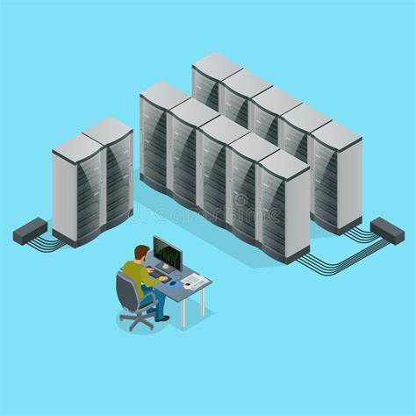

***Figure 4. Data Storage Center***

It offers speedy disaster recovery, little up-front costs, and easier extension. The only problem, though is the need to choose a [cloud](https://datafloq.com/read/?q=Cloud" \l "utm=internal" \t "_blank) associate. At the moment, it seems a hybrid approach with compliments to data storage is the way to go. It is very flexible, workable and provides varying data storage and access. The main problem, however, is to ensure that the process communicate well and share data whenever it is lacked.

### ***Security***

Private data is always valuable especially healthcare data. The healthcare industry must need to secure its client's data. Healthcare organizations must care about data security. All of the healthcare organizations have data storage centers and connect with high-speed internet. Medical data has great value because it's full of personal data. Hackers always want this kind of data. If a hacker can get this data may he can blackmail to the patients. This kind of situation is very dangerous for patients[6]. Malware attack is also dangerous for the data center. A strong malware attack can break down the security system and can destroy all the data of patients. If the data destroy once it will never come back. Healthcare organizations also must need to use anti-virus protection to protect the data.

### ***Stewardship***

Healthcare data is so important for doctors and patients for several year. Patients can need his medical data after six or seven-year later. This time healthcare organizations must need to give a person stewardship to protect the data. Stewardship gives a user to access his data[7]. It also helps patients to understand his medical data. By this method a patient can easily use his data, can understand doctor's report. Sometimes the researcher needs medical data to prevent the disease. They also can understand this data easily.

1. **Conclusion**

Big data is now one of the hottest topics in the world. Many researchers in the world now working on this topic. They are trying to use big data to make the healthcare industry more good. Scientists are now inventing new technologies. We can see modern technology very where. The healthcare industry is improving very fast. Past thirty years people are sick by different disease but doctors don't have any treatment for those kinds of disease especially cancer and HIV. But now some research groups improved the conditions. They use the previous data and trying to make a solution. Actually in healthcare organizations have a big amount of data. Researchers can analyze this data, can invent a new way to prevent that disease. People are now spending a huge amount of money to make sure that they are well. So it is healthcare organizations duty to give better care and outcomes. Big data analytics have several applications now helping doctors to understand patients much more better than past. In the future, it is possible to make a better healthcare system for patients by using big data analytics.

**Acknowledgement**

This work was supported by Chongqing science and technology innovation leading talent project (cstc2014kjcxljrc0037); Technology Development and demonstration Application Project of discrete Manufacturing Wisdom Factory for Automotive Intelligent Electronic Control system, Chongqing Municipal Science and Technology Committee (cstc2017rgzn-zdyfX0008); Chongqing Basic and Frontier Research Project(cstc2015jcyjA00031); Airport baggage intelligent sorting system, Chongqing Internet of Things Industry Development Special Fund(cstc2015zdcy-ztzx0205); Electrical fault diagnosis method for acid separator in natural gas gathering and transportation station, Chongqing University of Science and Technology Graduate Technology Innovation Project (YKJCX1720409).

**References**

1. Burghard C: Big Data and Analytics Key to Accountable Care Success. 2012, IDC Health Insights

[Google Scholar](http://scholar.google.com/scholar_lookup?title=Big%20Data%20and%20Analytics%20Key%20to%20Accountable%20Care%20Success&author=C.%20Burghard&publication_year=2012" \t "_blank)

1. Dembosky A: “Data Prescription for Better Healthcare.” Financial Times, December 12, 2012, p. 19. 2012, Available from: [http://www.ft.com/intl/cms/s/2/55cbca5a-4333-11e2-aa8f-00144feabdc0.html#axzz2W9cuwajK](http://www.ft.com/intl/cms/s/2/55cbca5a-4333-11e2-aa8f-00144feabdc0.html" \l "axzz2W9cuwajK" \t "_blank)[Google Scholar](http://scholar.google.com/scholar_lookup?title=%E2%80%9CData%20Prescription%20for%20Better%20Healthcare.%E2%80%9D%20Financial%20Times%2C%20December%2012%2C%202012%2C%20p.%2019&author=A.%20Dembosky&publication_year=2012" \t "_blank)
2. Explorys: Unlocking the Power of Big Data to Improve Healthcare for Everyone.[https://www.explorys.com/docs/data-sheets/explorys-overview.pdf](https://www.explorys.com/docs/data-sheets/explorys-overview.pdf" \t "_blank)
3. Intel: Leveraging Big Data and Analytics in Healthcare and Life Sciences: Enabling Personalized Medicine for High-Quality Care, Better Outcomes. 2012,[http://www.intel.com/content/dam/www/public/us/en/documents/white-papers/healthcare-leveraging-big-data-paper.pdf](http://www.intel.com/content/dam/www/public/us/en/documents/white-papers/healthcare-leveraging-big-data-paper.pdf" \t "_blank),[Google Scholar](http://scholar.google.com/scholar_lookup?title=Leveraging%20Big%20Data%20and%20Analytics%20in%20Healthcare%20and%20Life%20Sciences%3A%20Enabling%20Personalized%20Medicine%20for%20High-Quality%20Care%2C%20Better%20Outcomes&publication_year=2012" \t "_blank)
4. Connolly S, Wooledge S: Harnessing the Value of Big Data Analytics. 2013, Teradata[Google Scholar](http://scholar.google.com/scholar_lookup?title=Harnessing%20the%20Value%20of%20Big%20Data%20Analytics&author=S.%20Connolly&author=S.%20Wooledge&publication_year=2013" \t "_blank).
5. Bollier D: The Promise and Peril of Big Data. 2010, Washington, DC: The Aspen Institute [Google Scholar](http://scholar.google.com/scholar_lookup?title=The%20Promise%20and%20Peril%20of%20Big%20Data&author=D.%20Bollier&publication_year=2010" \t "_blank)
6. Zikopoulos PC, DeRoos D, Parasuraman K, Deutsch T, Corrigan D, Giles J: Harness the Power of Big Data. 2013, McGraw-Hill: The IBM Big Data Platform [Google Scholar](http://scholar.google.com/scholar_lookup?title=Harness%20the%20Power%20of%20Big%20Data&author=PC.%20Zikopoulos&author=D.%20DeRoos&author=K.%20Parasuraman&author=T.%20Deutsch&author=D.%20Corrigan&author=J.%20Giles&publication_year=2013" \t "_blank)